Computer Basics

------------------------------

*Computer consists of Hardware & Software

Hardware -> Computer`s physical components

Software -> set of instructions that directs the hardware to accomplish a task.

**** Introduction to hardware ***

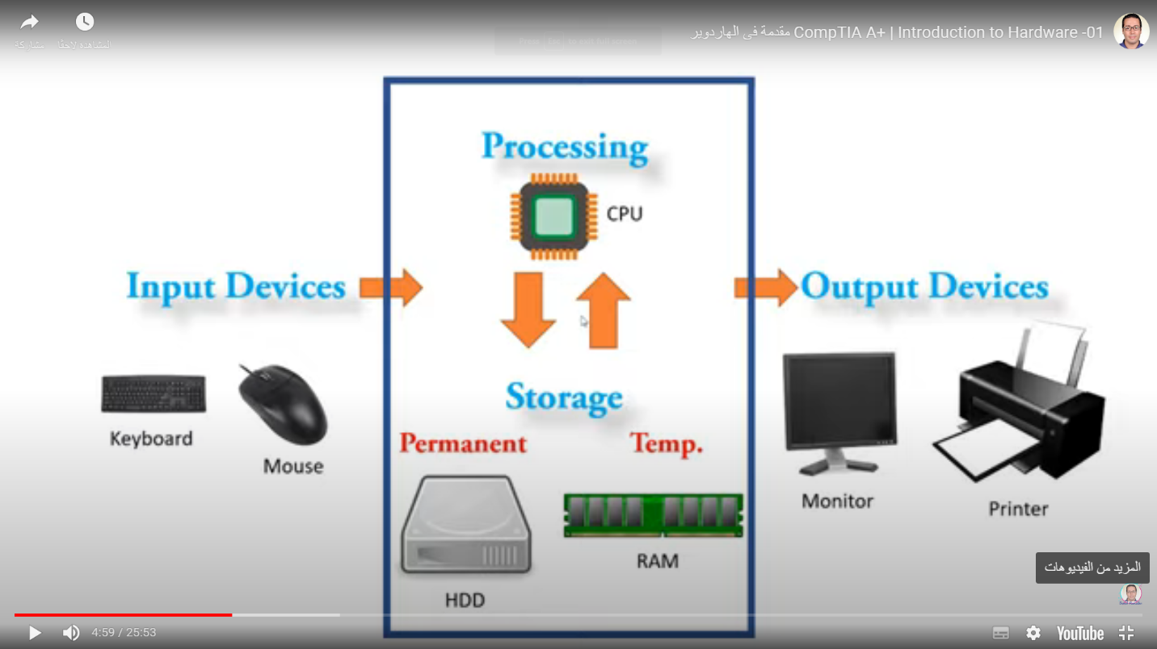

* Hardware jobs
  1. Input devices
* keyboard & mouse
  1. Processing
     1. CPU

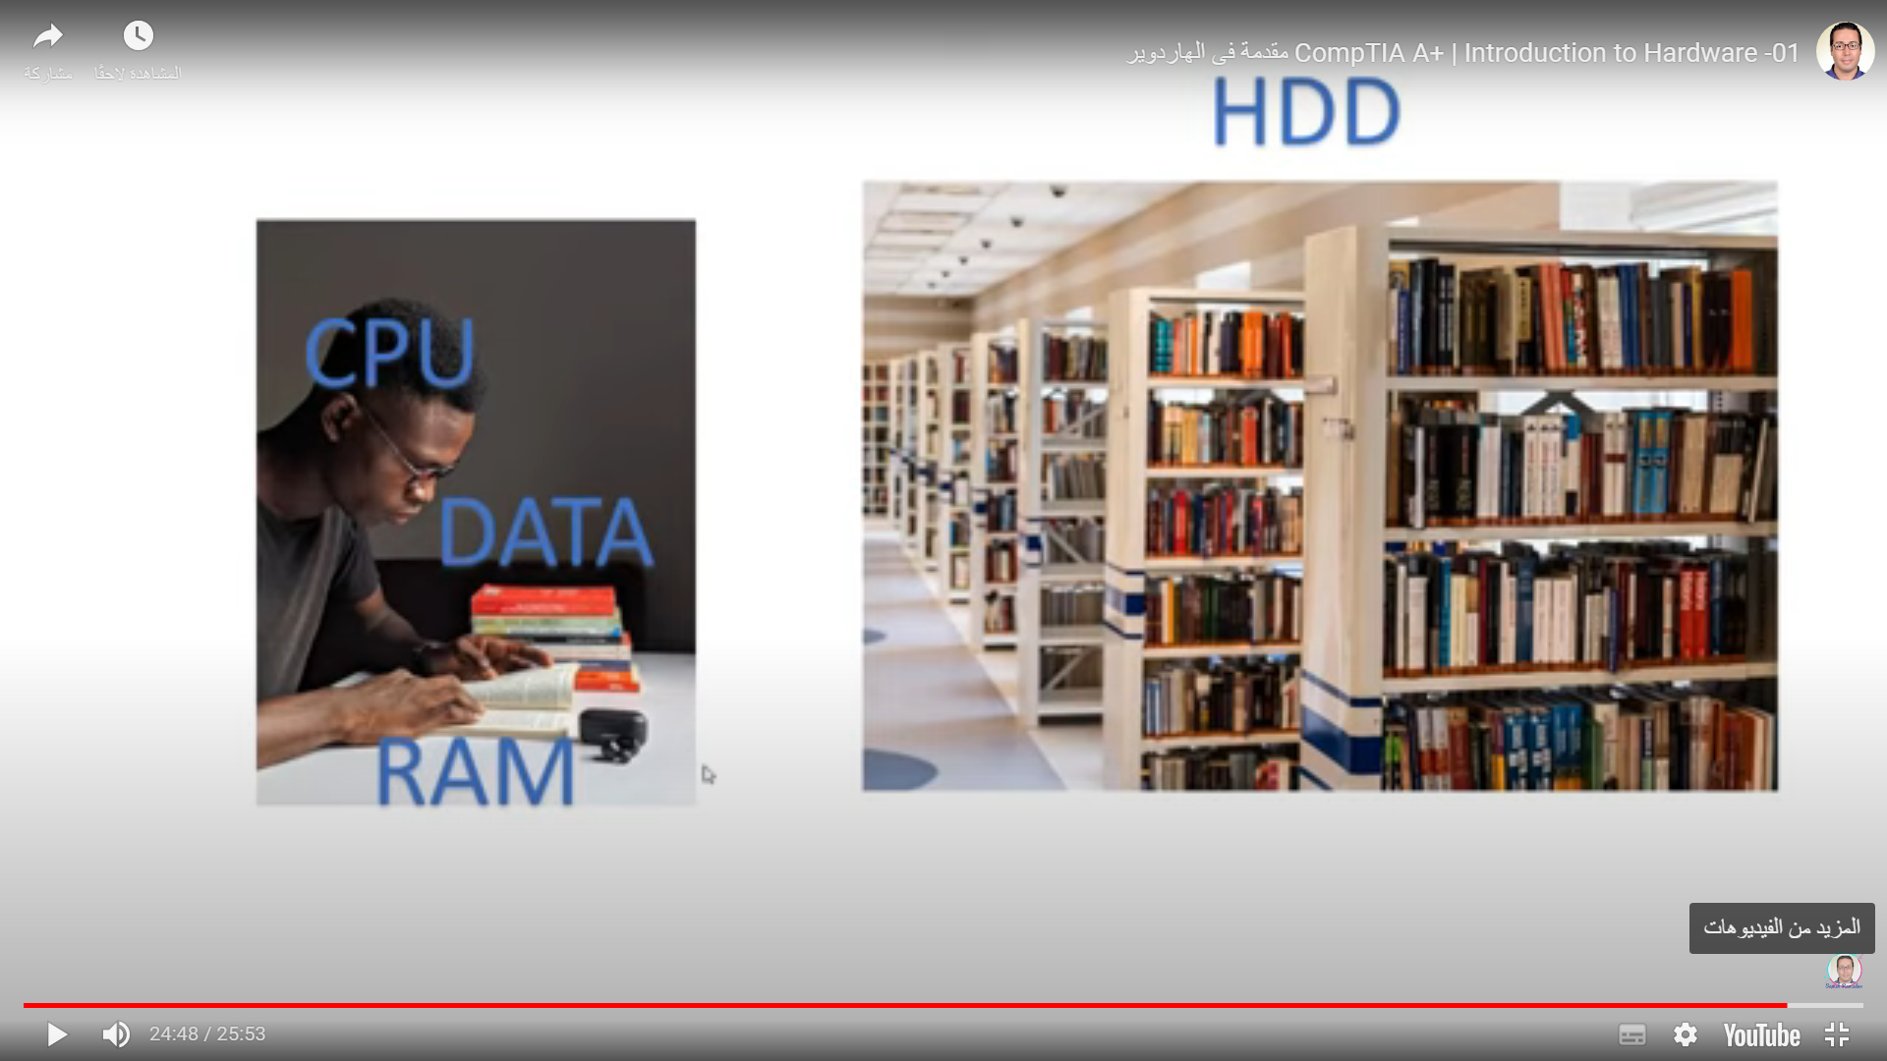

* 1. Storage
     1. Permanent -> HDD
     2. Temporary -> RAM
  2. Output devices
     1. monitor & printer
  3. Power Supply (PSU)

NOTES

* + 1. اى بيانات بتبقى موجوده على الهارد وعلشان فى فرق سرعه كبييير بين الهارد والبروسيسور فعملنا الرام بيتبقى موجوده جنب البروسيسور)

___________________________________________

**Power Supply**

Electricity

* + Voltage Pushes Ampere Through Resistors.
    1. Conductor
       - copper & gold
    2. Insulator
       - glass ceramic
    3. Semiconductor
       - silicon
    4. Units
       - Volt (V) -> Electrical Differential
       - Amp (A) -> Electrical current
       - Watt (W) -> Electrical power (V * A)
       - Ohm() -> Resistance To Electricity
* Some common electronic components
  1. Transistor
* Store electricity
* Amplifier -> strengthening the electric charge.

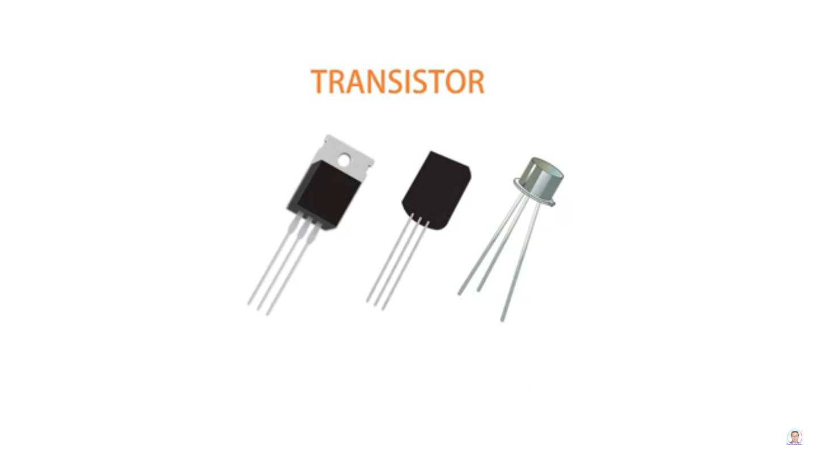

* 1. Capacitor
* As tank to store the electrical current

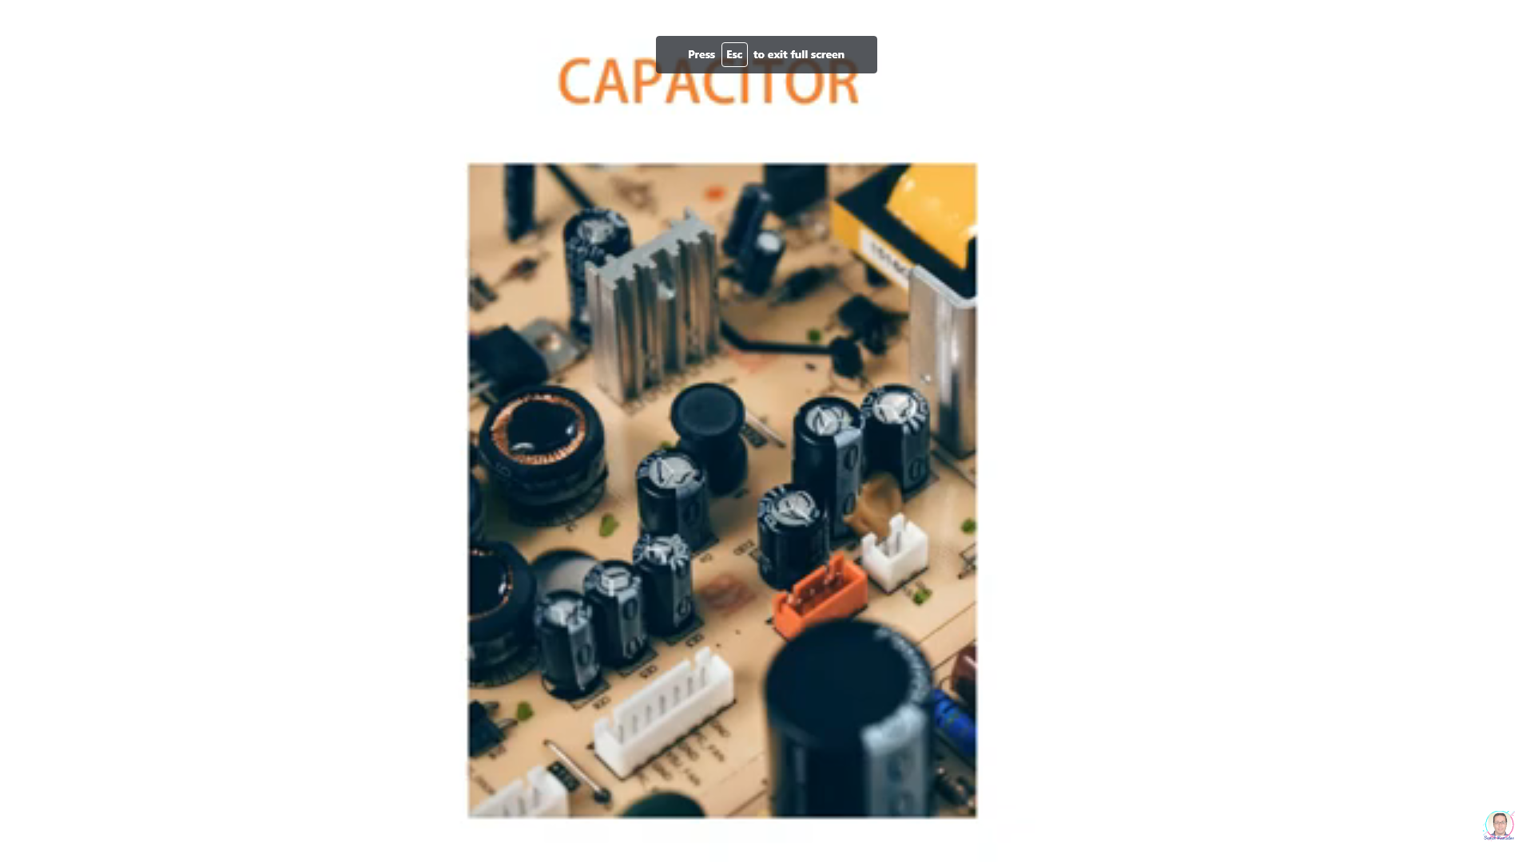

* 1. Resistors
* Control in electric current
  1. Fuse
* Prevents high flow of electric current.
* (لو التيار عالى فالماده بتنصهر وهتمنع سريان التيار فى الدايره)
* Electrical Current
  1. DC (Direct Current)
* The Electric Current is High
* It is used in computer components.
  1. AC (Alternating Current)
* It`s called alternating current because it moves between positive & negative.
* It moves long distances.
* Increase the voltage & reduce the electric current.
* It used in homes.
  1. Transformer
* Reduce the current & increase voltage
  1. Rectifier
* Convert AC into DC
  1. Hot
* Line from power station to home
  1. Neutral
* Line from device to power station
  1. solving of short (القفله)
* connect neutral with ground

Roles

* Rectifier
* Convert AC into DC (in computer)
* Transformer
* Reduce voltage from 220 to (+5 | +12 | +3.3 | -12)

ESD (Electrostatic Discharge)

* Static Electricity
* ESD Damage
  1. Catastrophic Failure
  2. Upset Failure
* Solution
  1. Ground Bracelet

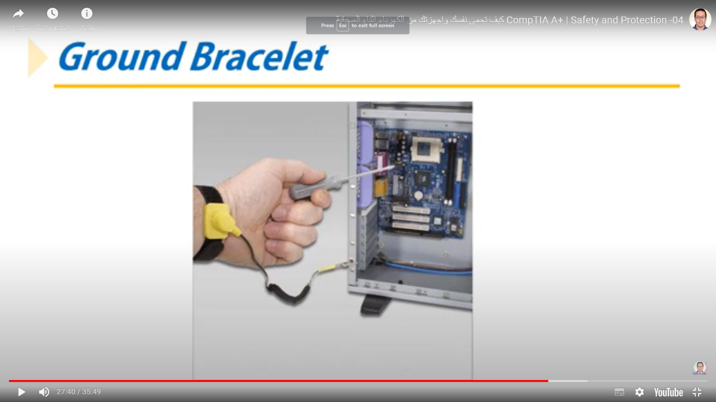

* 1. Ground Mats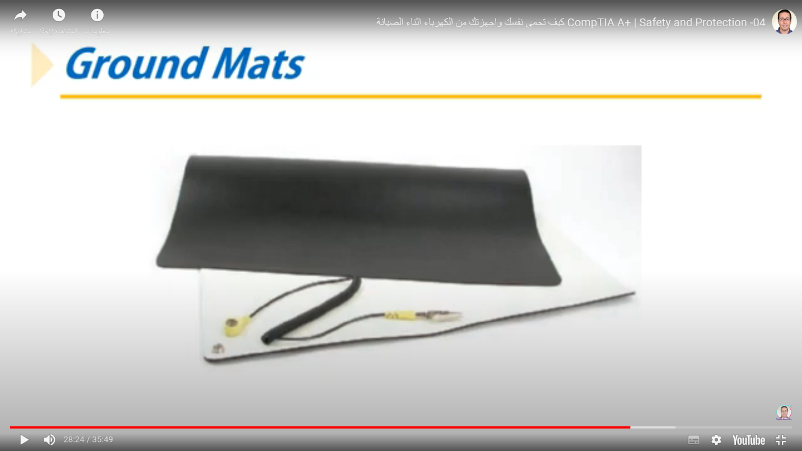
  2. Static shielding bags
  3. Antistatic gloves

Power Supply Features

* Form factor
  1. ATX & Micro ATX
* Wattage Rating
  1. Calc Wattage Capacity
* Video cards draw the most power.
* 30 percent higher than expected needs.
* 12V Rail
* every electrical circuit within the power supply is called rail.
* Usually, each rail has more than one cable

Number and type of connectors

* P1 Connector
* 4-pin 12V auxiliary connector
* Supply processor
* Molex 4-pin connector
* Use with ide devices
* SATA Connector
* SATA Devices (ex -> DVD)
* Floppy Drive Connector
* 6 pin 12V PCle Connector
* Use with video cards.

Fans Inside The PSU

Dual Voltage Option

* (لما انقل جهاز من بلد لبلد لازم اخلى بالى من التغيير فى فرق للبجهد)

Other Features

* Warranty
* Modular (without cables )
  + - (بييج الكابلات لوحدها وانت بتركب اللى محتاجه وده احسن علشان ميعملشى زحمه داخل الكيسا وكده هيقلل مسار الهواء) VS Non-modular PSU
* Gaming Computer Support
* SLI / Crossfire (تقدر تركب كرتين فيديو مع بعض)
* Protection
* ( لو فرق الجهد جاى عالى فهى بتقلله علشان ميبوظشى الكمبونينت وده مش بيبقى فى كله )

NOTES

* + - * FRU (Field Replaceable Unit) -> power Supply & CRT monitor

____________________________________________

**Motherboard**

Components

* + P1 Connector
* the place where the Power Supply will be installed
  + PCI Slots
* the place where the additional cards will be installed

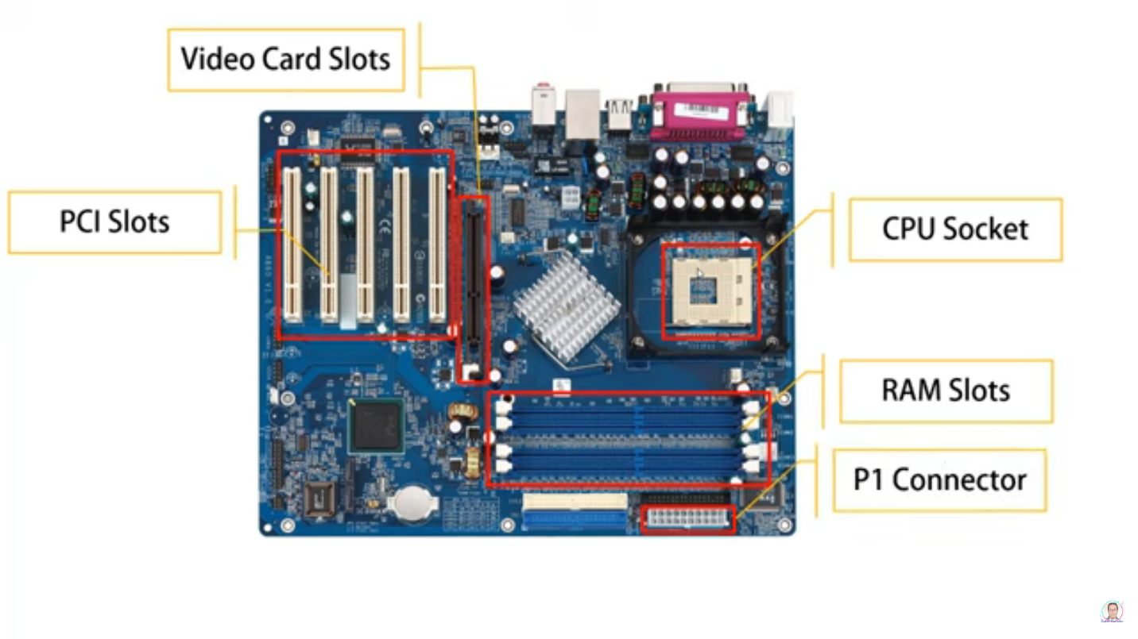

Roles

* + provide a communication system in case.
  + distributed energy
* it gets energy from power supply and gives it to the components.

VIP

* + Processor
  + Type of motherboard

To determine type of motherboard

1) Form Factor, 2) Process Socket, 3) Chipsets ,

4) Buses & Slots, 5 ) I/O Inputs , 6) Extra Features

1. Form Factor

* ATX, microATX, Mini-ITX

1. Processor Socket

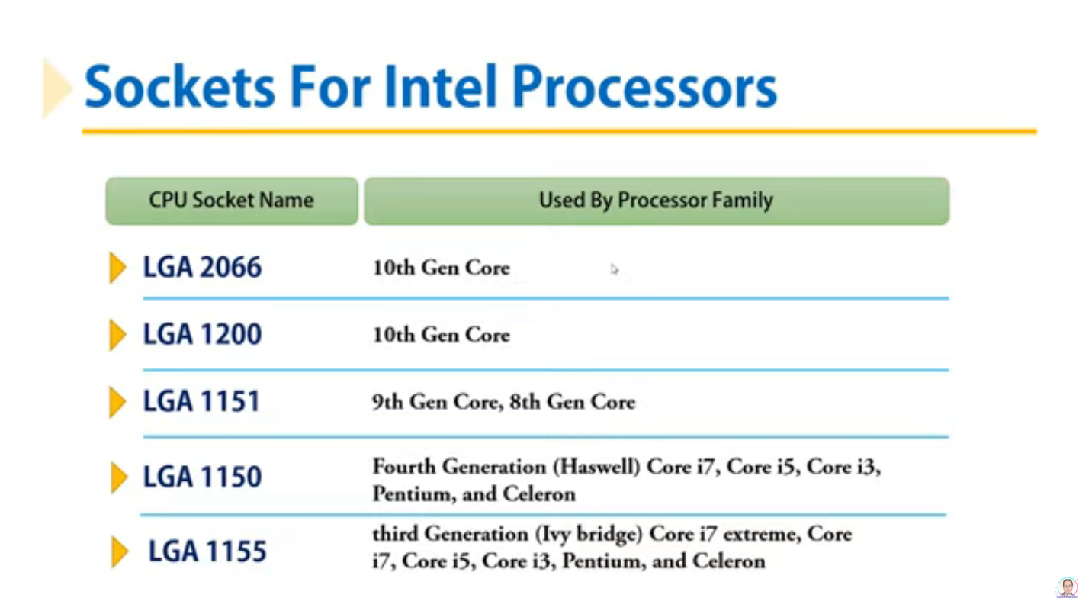

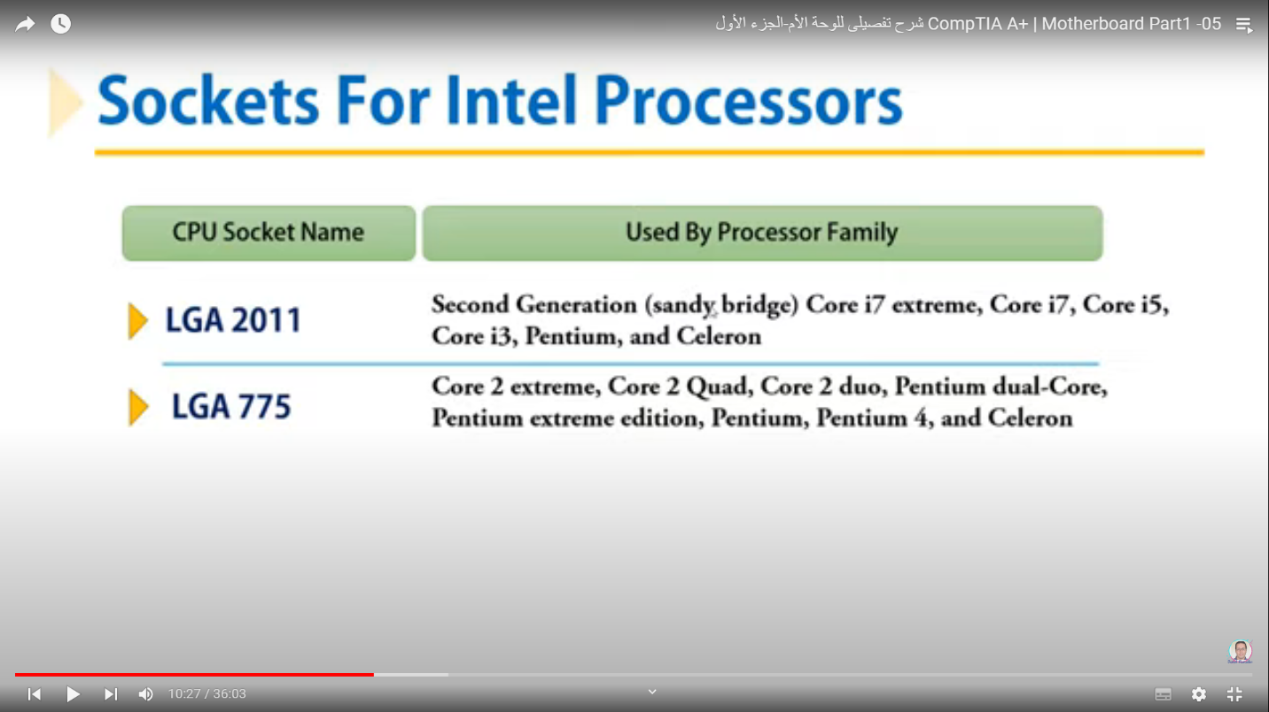processor connection methods with sockets

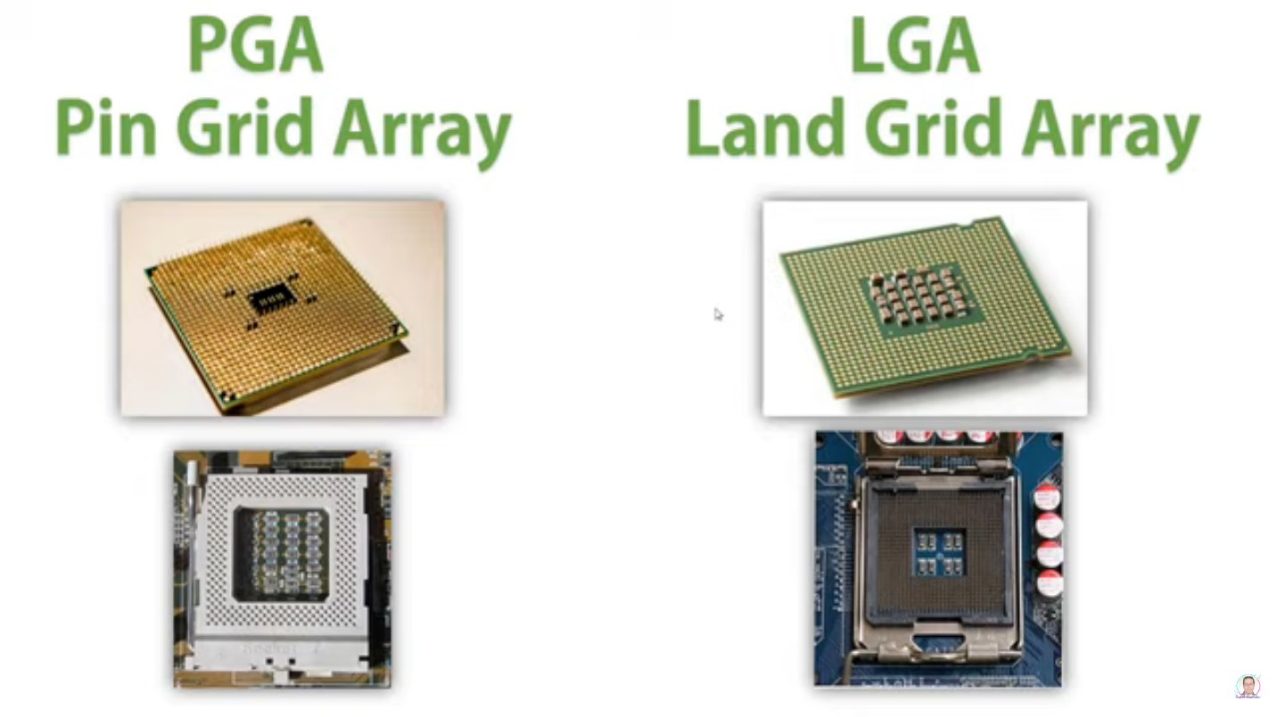

PGA (Pin Grid Array)

* Processor (Pins), Sockets (holes)

LGA (Land Grid Array)

* (خلت البينز متماسكه و كثيفه وصغيره وبقت موجوده فى السوكيت)
* Sockets (pins)
* Processor (pads)
* Installation (Easy)

Zero Insertion Force (ZIF)

* (دراع موجود فى السوكيت علشانن يسهل تثبيت البروسيسور)

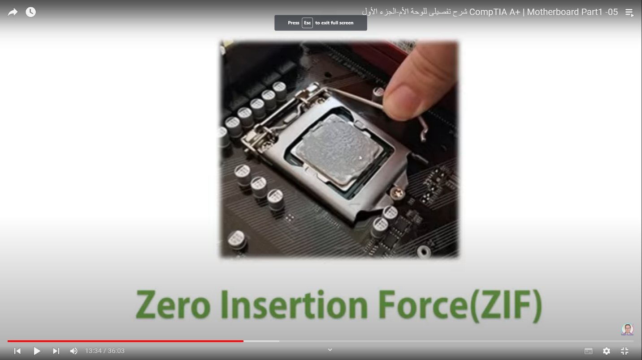

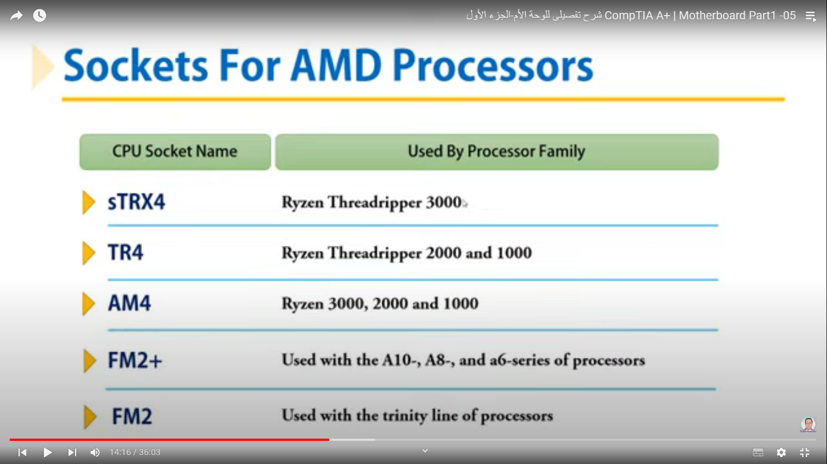

1. Chipsets
   * + (البروسيسور علشان يتكلم مع الرام عن طريق الرام كنترولير وهى موجوده داخل الشيبس)

Intel Chipsets

**1) North Bridge & South Bridge use a hub architecture**

* + - * + Intel i800 series
        + Hub using the Accelerated Hub Architecture

(يتكون من طرفين واحد سريع اسمه نورث بردج والبطئ اسمه سوس بريدج)

* **North bridge -> Graphics & Memory Controllers**
  + - Front Side Bus (FSB) (الناقل من ال س ب يى لل نورث)

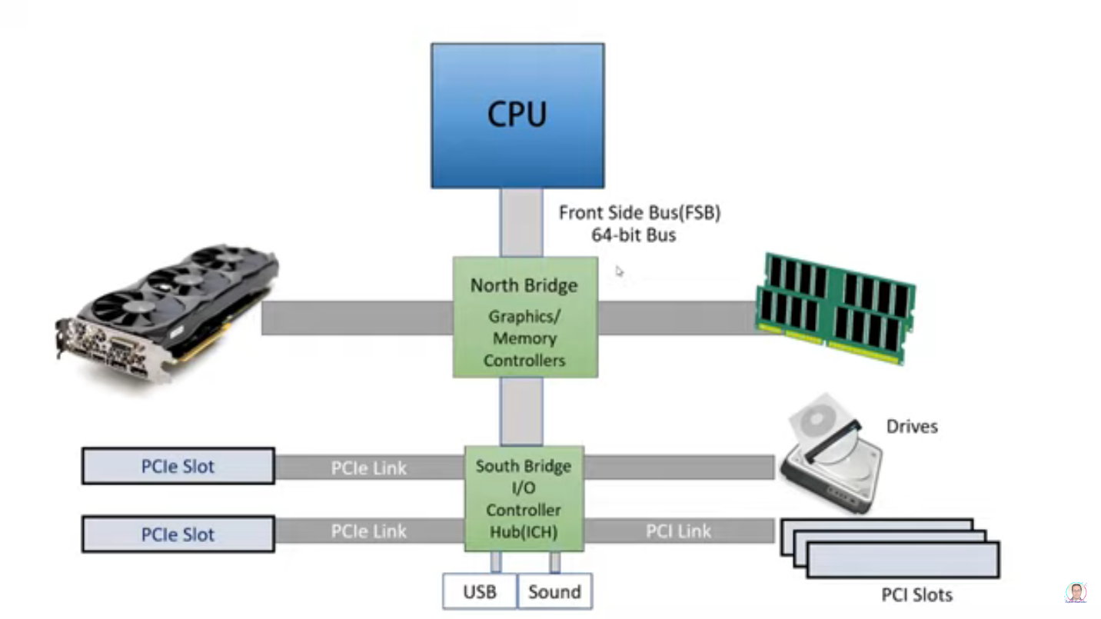

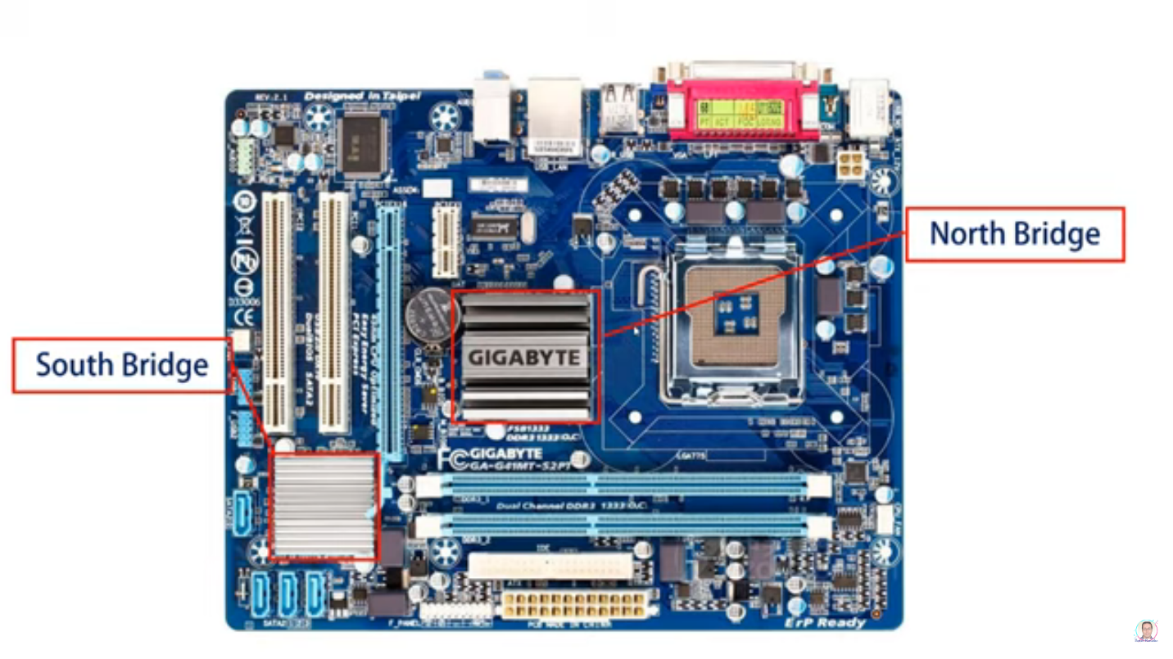

1. **Nehalem chipsets with the memory controller in the processor**

* The release of the X58 chipset in 2008
* (خدت الميمورى من النورث وحطيته فى البروسيسور هوستينج يعنى جنب الس بي يو علشان يوصله بسررعه)
* Consider the first generalization from chipsets.
* Support the intel LGA1366 socket & Core i7 & PCI Express Version 2 & SLI or CrossFire

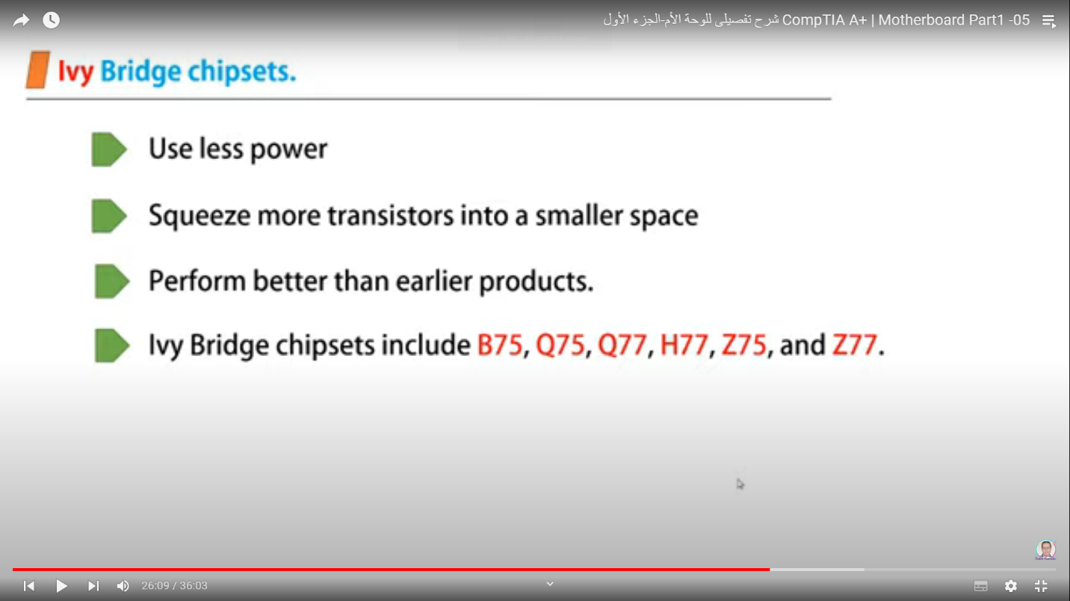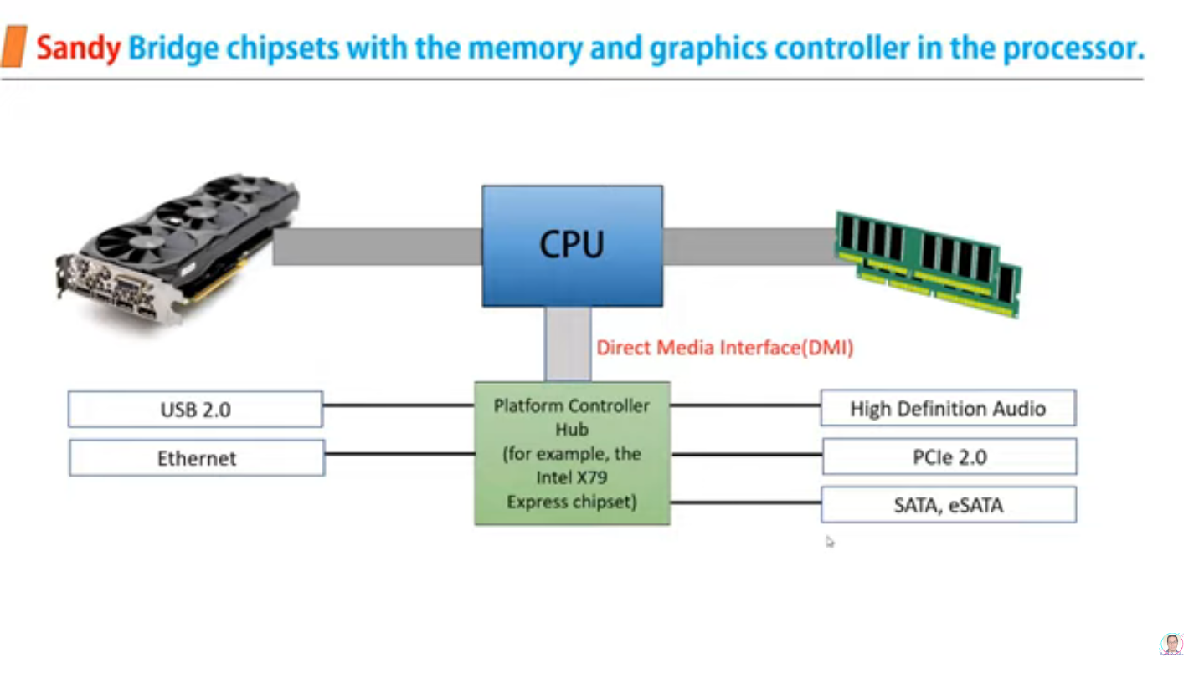

1. خد الجرافيك من النورث وحطه جنب السى بي يو)
2. **Ivy Bridge chipsets (Third)**
3. **Haswell & Broadwell chipsets (forth)**

AMD Chipsets

* Accelerated Processing Unit contains.

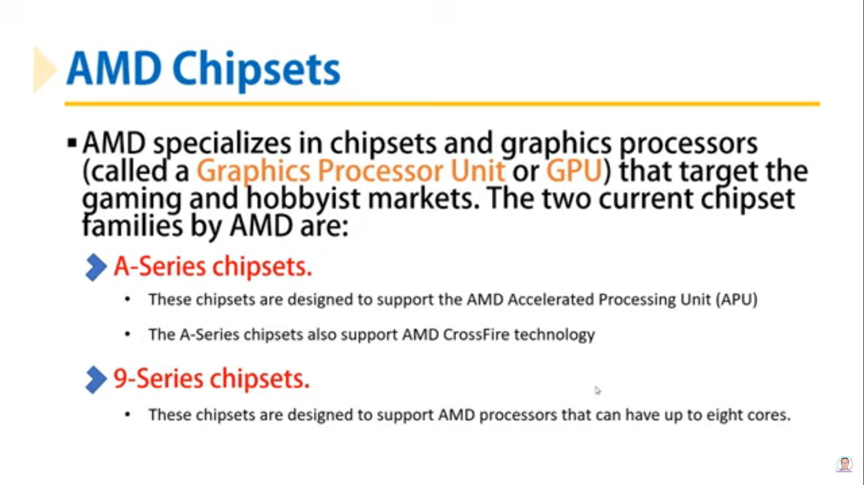

1. Buses & Slots

* Traces
  + - transmit data & instruction to components

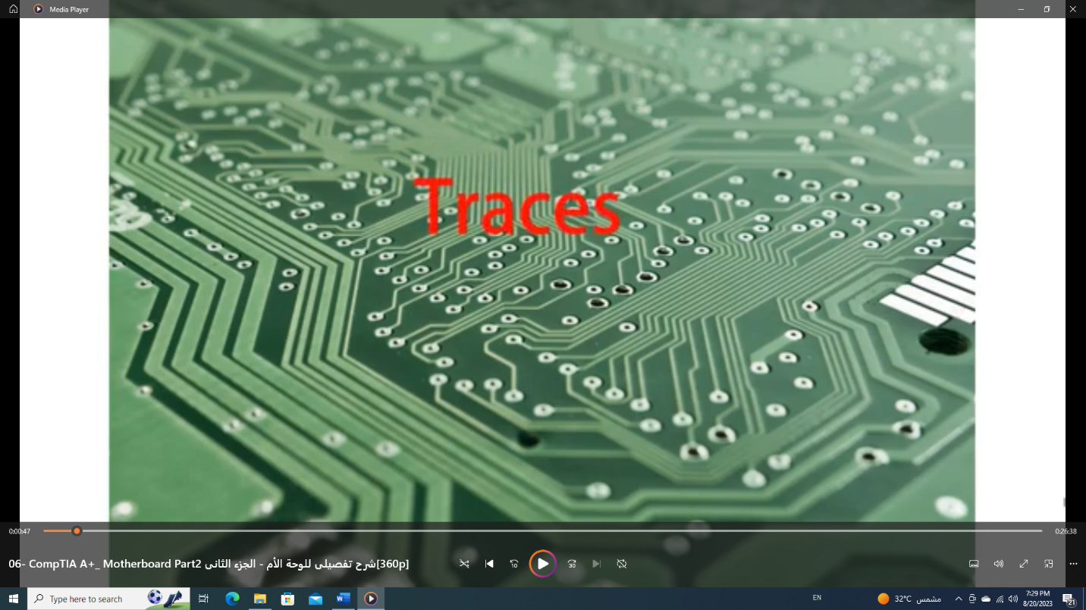

* Bus
  + - transmit Electrical Power & Control Signals & memory Address & data.
    - Consists of multiple lines (Data Path Size).
    - Data Path Sizes -> 8-bits , 16-bit , 32-bit , 64-bit , 128-bit

NOTES

* How Bus Transfer Data between components?
  + They must be in Sync.
  + Voltage between them.

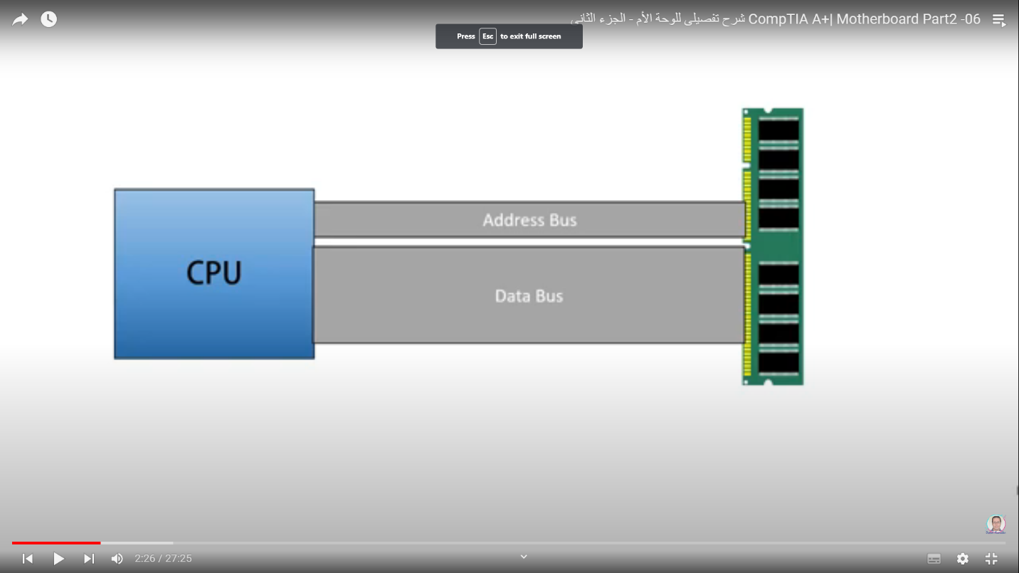system clock (System Timer)

* + Component synchronization process
  + (لو فى اتنين كمبونينت عايزين يتكلموا فالعمليه دى على اسااس الكلوك)
  + The frequency(speed) of memory, Front Side Bus, Processor, or other component is measured in hertz(Hz) -> one cycle per second

NOTES

* Some of components can do multiple activities in one clock. Ex (CPU)
* Some of components can do one activity through several Clock ( not in Sync )

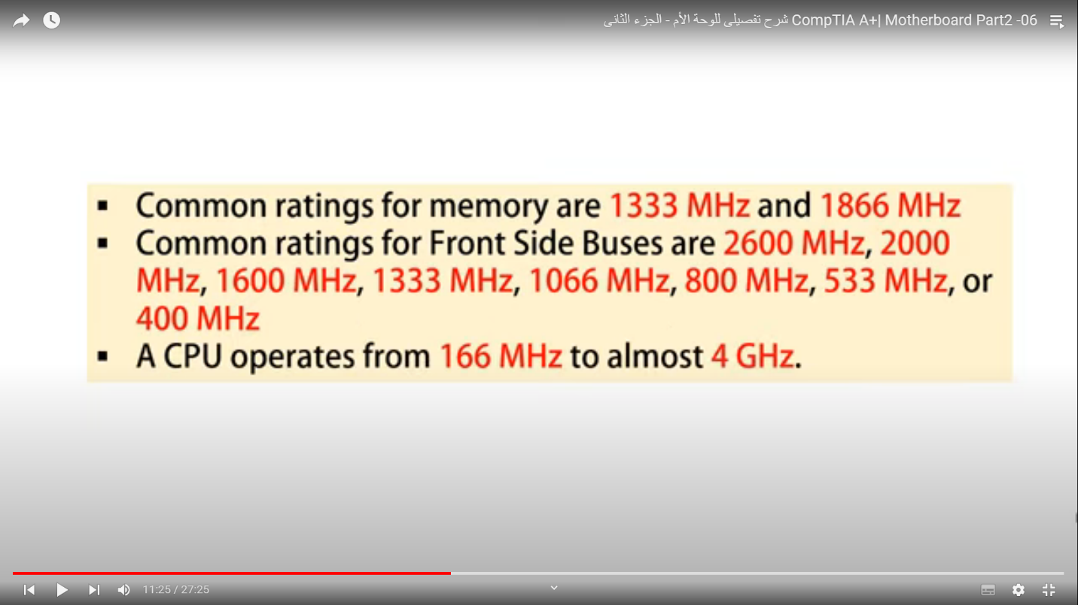Expansion Slots

(To Addition cards to motherboard)

* Conventional PCI (Prefer Component interconnect)
  + 1. 32-bit PCI Slots & 64-bit PVI Slots
       - Before feature -> Supply card with 5 V & 33 MHz
       - After feature -> supply card with 3.3V & 66 MHz
    2. A Universal PCI card
       - can use either a 3.3V or 5V slot and contains both notches
    3. Enhance PCI
* PCI-X

Compatible with PCI

Especially for server devices

* + 1. PCI Express (PCIe)

Consider future technology.

Not compatibility with PCI & PCI-X

comes in four different slot sizes

x1, x4, x8, x16

x1 -> contains a single lane for data; this lane is actually four wires. One pair of wires is used to send data and the other pair receives data. -> Receiving & sending can be done at the same time

x16 (used for VIGA Cards -> 16 lanes (8 for Receiving & 8 for Sending)

NOTES

* Notch
* To ensure where to put the card.
* The difference between PCI & PCIe
  + - * + PCI -> Parallel Bus, PCIe -> Serial Bus
        + Technology in PCIe -> USB & FireWire & Ethernet
      * PCIe Performance is better than PCI.
      * Each PCIe Slot has its own link.
      * All PCI Slots have one link that they share it.

1. I/O Ports (Onboard Ports & Connectors)

* USB Port number

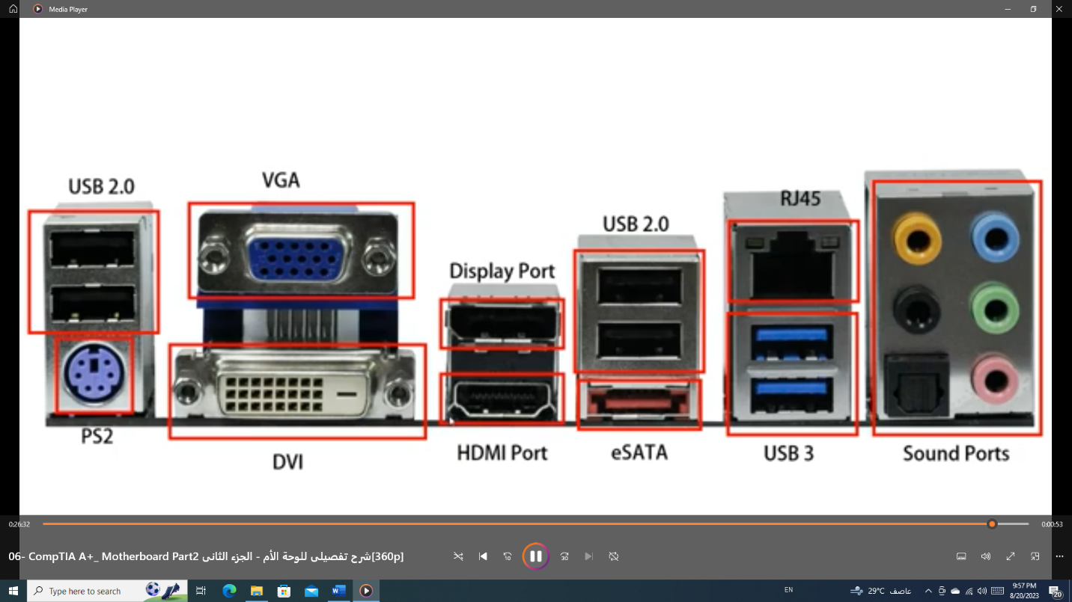

1. Extra Features

* Firmware
* It is a hardware chip that you can physically see and touch, and it includes software that runs code on the computer. The combination of hardware and software is firmware.
* Enable or disable a connector, port, or component.
* Control the frequency of the CPU.
* Security features
* What happens when the PC first Boots.
* Types

(BIOS, UEFI, UEFI With BIOS)

* + - BIOS (Basic Input Output System)

Enable CPU handle with ROM.

* + - * PC boot Process
        + Power -> CPU
        + CPU loads BIOS
        + POST (Power On Self-Test) operation

Checks BIOS code

BIOS on video board checked and loaded

Checks for other BIOS programs

Device check (RAM-Keyboard, … etc)

Search for boot drive

* + - UEFI
      * + Extensible Firmware Interface (EFI)

the original version of UEFI, was first developed by Intel

Today, Unified EFI (UEFI) is managed by several manufacturers and developers under the Unified EFI Forum (see [www.uefi.org](http://www.uefi.org)).

* + - UEFI With BIOS
* Maintaining a motherboard
  + Update the motherboard drivers.
  + Flash (update) BIOS or UEFI.
    - RESONS
      * The system hangs at odd times or during the boot.
      * Some motherboard functions have stopped working or are causing problems.
      * You want to incorporate some new features or component on the board.
    - METHODS
* Express BIOS update.
* Update from a USB flash drive using BIOS setup.
* Update using a bootable CD.
  + Replace the CMOS battery.
* Using jumpers to Clear BIOS Settings
  + Jumpers

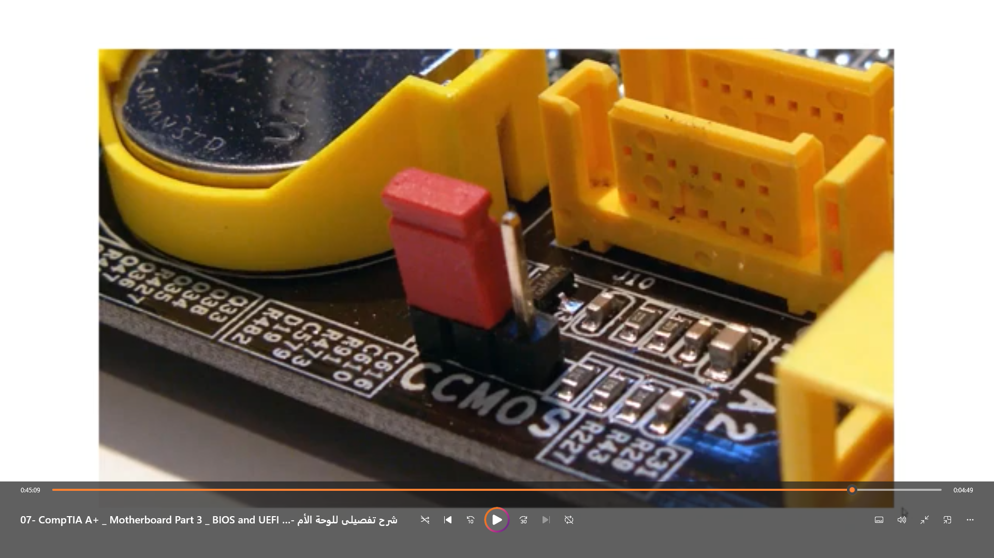

* + CMOS Ram
    - Replacing The CMOS Battery
      * CMOS Battery supply power to CMOS Chip
  + DIP swatches
* Major manufacturers of motherboards
  + [www.asus.com](http://www.asus.com)
  + [www.evga.com](http://www.evga.com)
  + [www.asrock.com](http://www.asrock.com)
  + [www.gigabyte.com](http://www.gigabyte.com)
  + [www.miscomputer.com](http://www.miscomputer.com)
  + www.supermicro.com.com
* NOTES
  + Why UEFI is better than BIOS
    - Faster and better booting
    - Mouse-enabled interface
    - Secure boot
    - Support for hard drives larger than 2 TB
      * + To partition hard drives
* Master Boot Record (MBR)
* 2 TB Drives
* 4 Partitions
* GUID Partition Table (GPT)
  + Greater than 2 TB Drives
  + 128 Partitions
  + GPT is required for drives larger than 2 TB or for systems that boot using UEFI firmware.
* Allows for backward compatibility. It can boot from a MBR hard drive and provides a BIOS boot through its CSM(Compatibility Support Module)

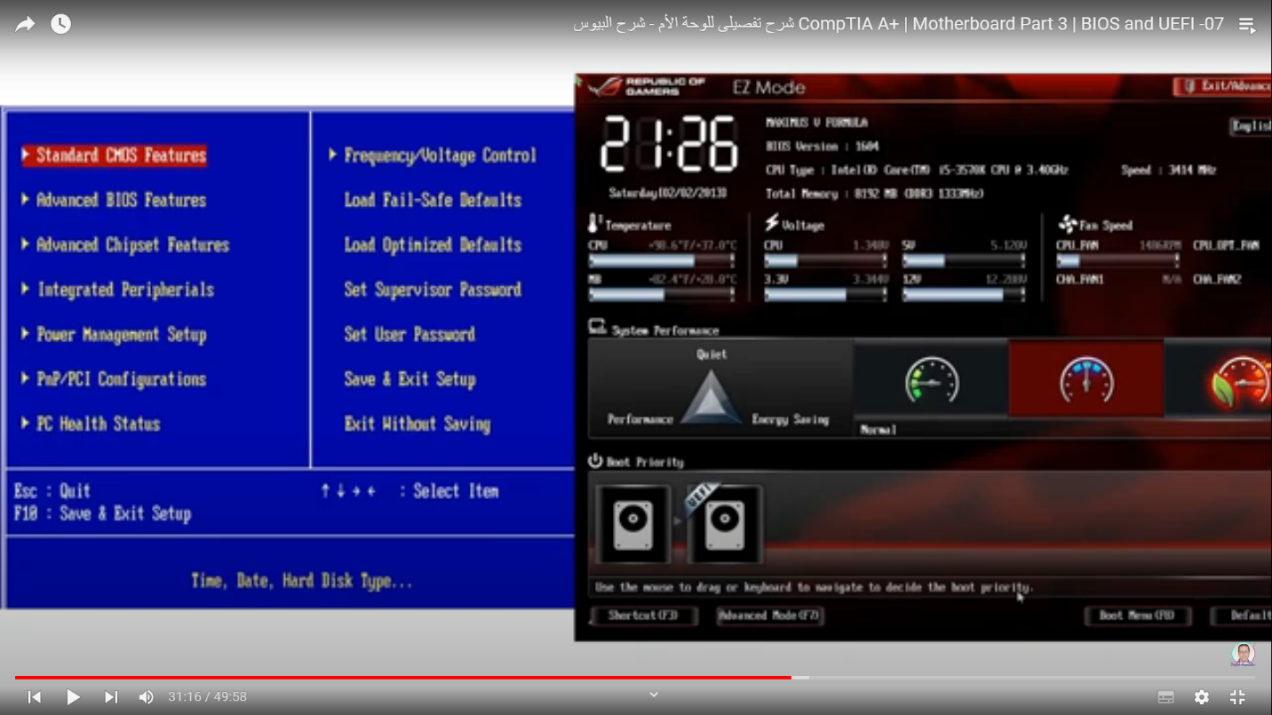

* CMOS (Complementary Metal-oxide Semiconductor)
* Consider Additional chip & inside ROM chip
* Includes info of components ex(size of RAM)
* BIOS Vs CMOS
  + - BIOS -> in ROM, Contains Programs,
    - CMOS -> in RAM, Contains Parameters, System clock (الساعه اللى بتظهر فى شريط المهام)
  + Types of Devices that is connected to the motherboard
    - * Devices have no configurable parameters (not changeable)
        1. Keyboard
      * Devices have configurable parameters (changeable)
        1. RAM
        2. CMOS Chip (RAM chip)
      * Custom devices
        1. Built-in-ROM

SCSI board

Video board

* + - * 1. Device drivers

Sound board

Network adapters

* + Using setup BIOS to Configure a MOTHERBOARD
    - Access the BIOS setup program
      * F2 || F9 || Del || Ctrl + Alt + Esc || search (BIOS Setup Key)

**processors**

How A Processor Works?

1. Data -> FSB (الناقل)
2. I/O Unit (Organizing data entry & exit)
3. Control Unit (Organizing the distribution of data & instructions that enter the ALU)
4. ALU (Arithmetic Logic Unit)
   * Puts data & instructions & counters in Registers.

NOTES

* FSB -> link between internal components (Processor Die) & Chipset

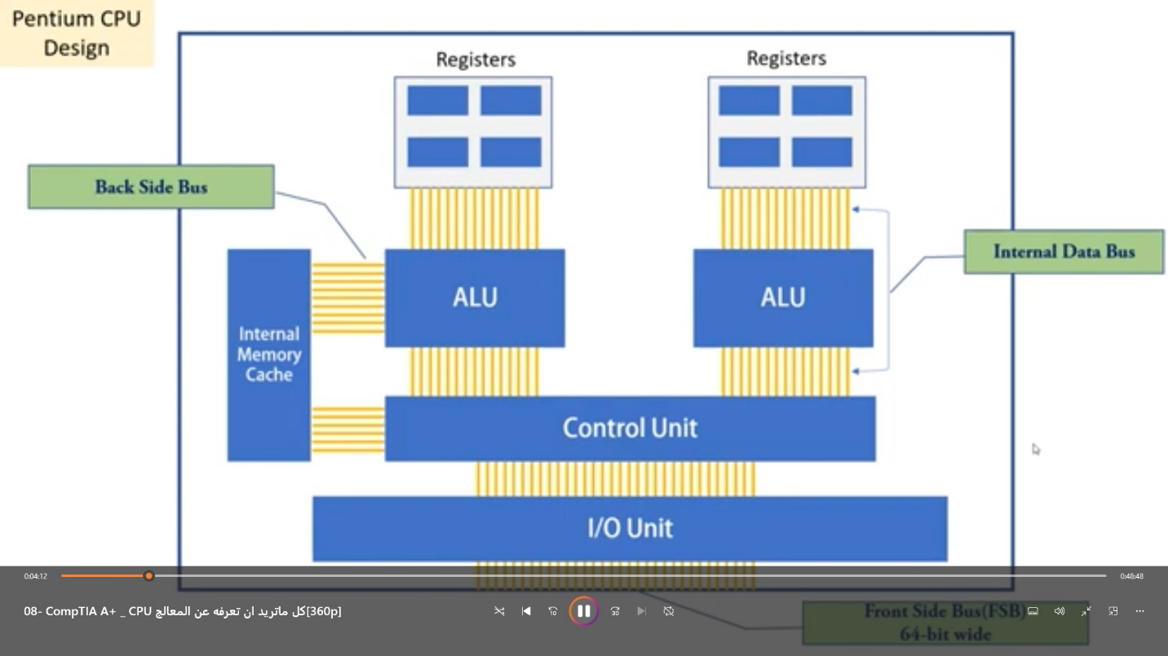

CPU Features?

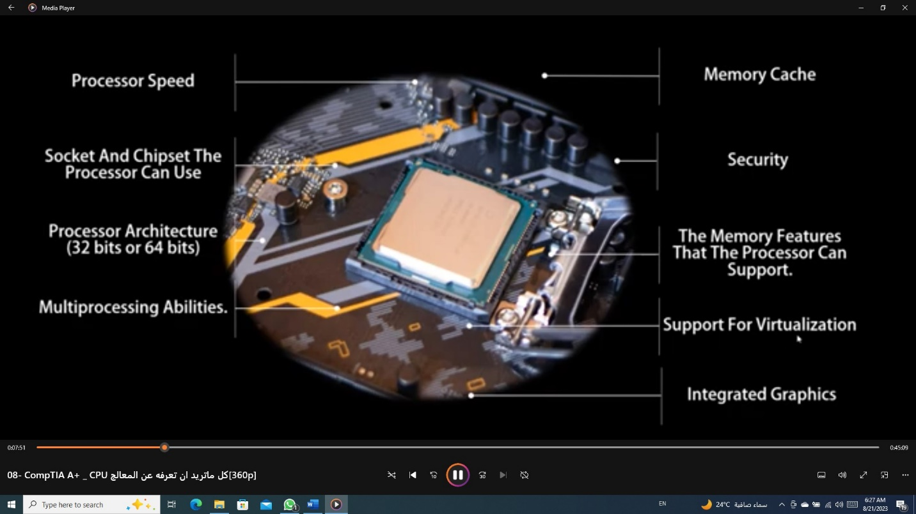

1. Processor Speed
   1. Current Intel & AMD processors run at 1.8 GHz up to more than 4.4 GHz.

NOTES

* Multiplier
  + It’s very important for Overclocking
  + It controls the CPU Speed
  + If FSB 800 MHz & CPU 3.2 GHz
    - (3.2 * 1000 = 3200 MHz/ 800 MHz = 4)
      * (كده السى بي يو بيعمل ب 4 اضعاف سرعه الناقل)
      * 4x -> Called Multiplier
* Overclocking
  + Increase the CPU Speed through Multiplier
    - Ex (it can turn multiplier from 4x to 8x)
  + But when you used it will increase the heat

1. Socket & Chipset the Processor Can Use
2. Processor Architecture (32 bits or 64 bits)
   1. 32-bit Processors (ancient)
      1. Known as x86 processors.
         1. Handle 32-bit of data from OS.
         2. In Intel all Processors finish with 86
   2. Processors that can process 32 bits or 64 bits
      1. Called hybrid processors or x86-64 bit processors
      2. AMD was the first to produce one (the Athlon 64) and called the technology AMD64.
      3. Intel followed with a version of its Pentium 4 processors and called the technology Extended Memory 64 Technology (EM64T)
      4. OS -> 32bit || x64 || x86
         1. Memory capacity distinguishes dealing with each one of them.
            1. If X86-> OS will Deal with 4G from RAM
            2. If x64 -> OS will Deal with 4G or more from RAM

NOTES

1. Pentium 4
   * the first processor, support hybrid (means you can used 32 bits or 64 bits)
   1. 64-bit processors
      1. Fully implemented 64-bit processing
         1. OS -> 64-bit
      2. Itanium & Xeon processors
         1. Use of workstation devices || servers
      3. Intel calls the technology IA64, but they are also called x64 processors
2. Multiprocessing Abilities
   1. Multiprocessing
      1. It is a link with the number of ALU.
   2. Multithreading
      1. OS divide data to threads, Threads are distributed on more than ALU, then sends it to processor.
      2. Intel calls this technology Hyper-Threading
      3. AMD calls it HyperTransport
      4. The feature must be enabled in UEFI/BIOS setup & the OS must support the technology.
   3. Multicore processing
      1. Core fully implemented as a CPU.
   4. Dual processors
      1. Motherboard made to receive multi of processors.
      2. In workstation || server
3. Memory Cache
   1. Inside the CPU
   2. It includes the data that CPU is needed a lot.
   3. l1 -> is the fastest & the nearest & includes the instruction that processor is need it & size (capacity) is little (KB)
   4. l2 -> the speed is less than L1, capacity (MB) is more than L1.
   5. L3 -> in some processor, is shared.
   6. processor search in L1-cache and if not found data in it, it searches in L2-Cache

NOTES

1. 3/6
   * 3-> processor speed
   * 6 -> ( L2-Cache || L3-Cache ) Speed

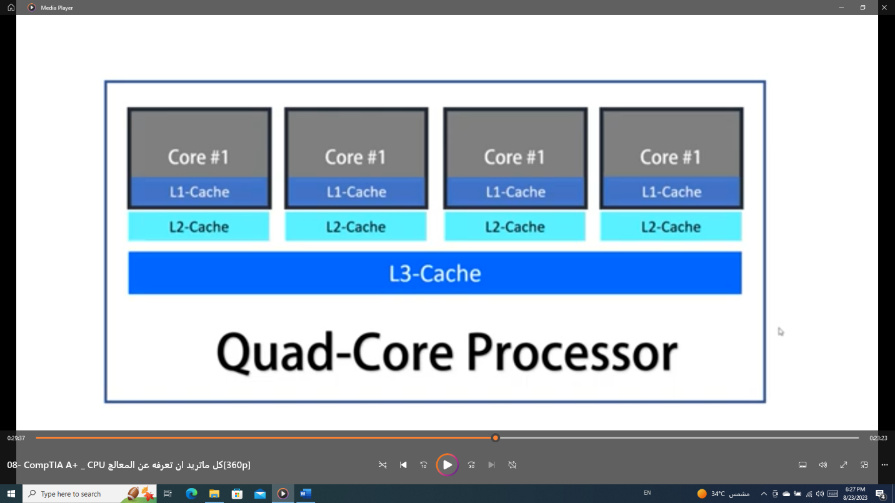

1. Security
   1. Execute Disable Bit (EDB)
      1. Also called eXecute Disable [XD] by Intel, Enhanced Virus Protection by AMD
      2. EDB requires a compatible OS. You can enable EDB using the BIOS or UEFI setup screen.
      3. EDB & OS
         1. Store space in RAM to store data of applications.
         2. It prevents damage caused by the Virus.
         3. It can stop malware from executing, it cannot remove it. You still need to use anti-malware sw to remove the malware.
2. The Memory features on the motherboard that the processor can support.
   1. The characteristics between CPU & Memory
      * 1. DDR, DDR2, or DDR4
        2. Amounts Of Memory
        3. Memory Speed
        4. Memory Channels
3. Support For Virtualization
   1. Most processors sold today support virtualization.
   2. The feature must be enabled in UEFI/BIOS setup.
4. Integrated Graphics
   1. A Graphics Processing Unit(GPU) that manipulates graphic data to form the images on a monitor screen.
   2. Many AMD processors & all the Intel second generation and higher processors have integrated graphics.

NOTES

Processor Data Views

* + This PC -> Properties
  + System Information || win+r msinfo32
  + Taskbar + right click + task manager + performance
  + CPU-Z

I5-2400 -> second generation

4 Cors, 4 Logical Processor -> it doesn’t support hybrid processor, because the number of Cors is the same as Logical processor

Computer generalization

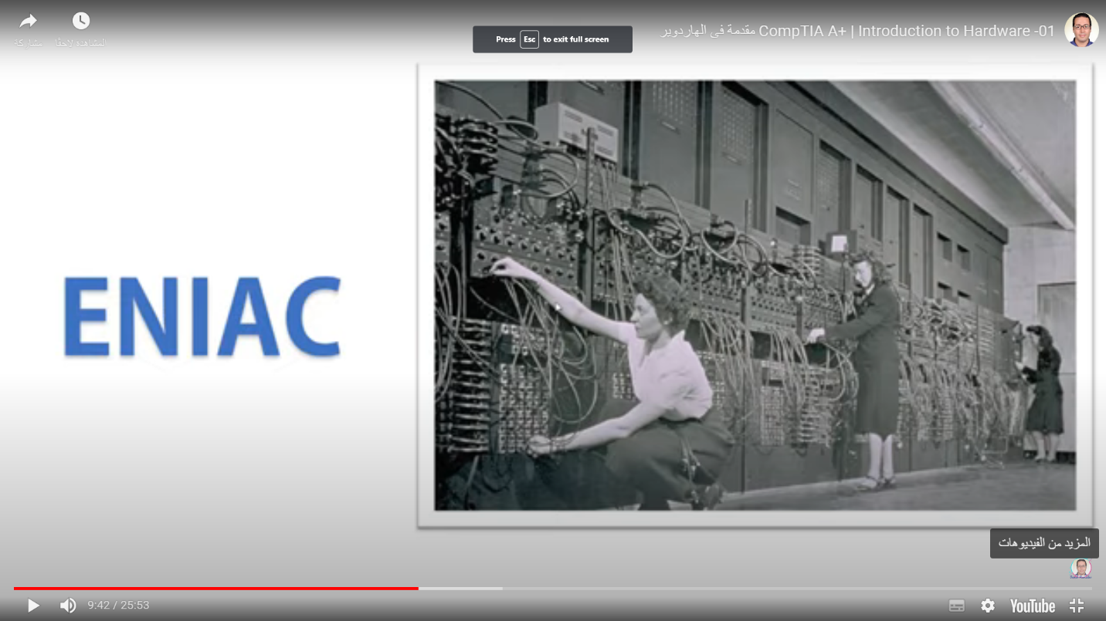

Data

* + - stored in Vacuum Tubes
    - ( كل ما اديها رقم الشحنه الكهربيه هتزيد جواها فكانت مشكلته ان لظروف فيزيائيه الرقم ممكن يتغير وبالتالى القراءه هتبقى غلط)

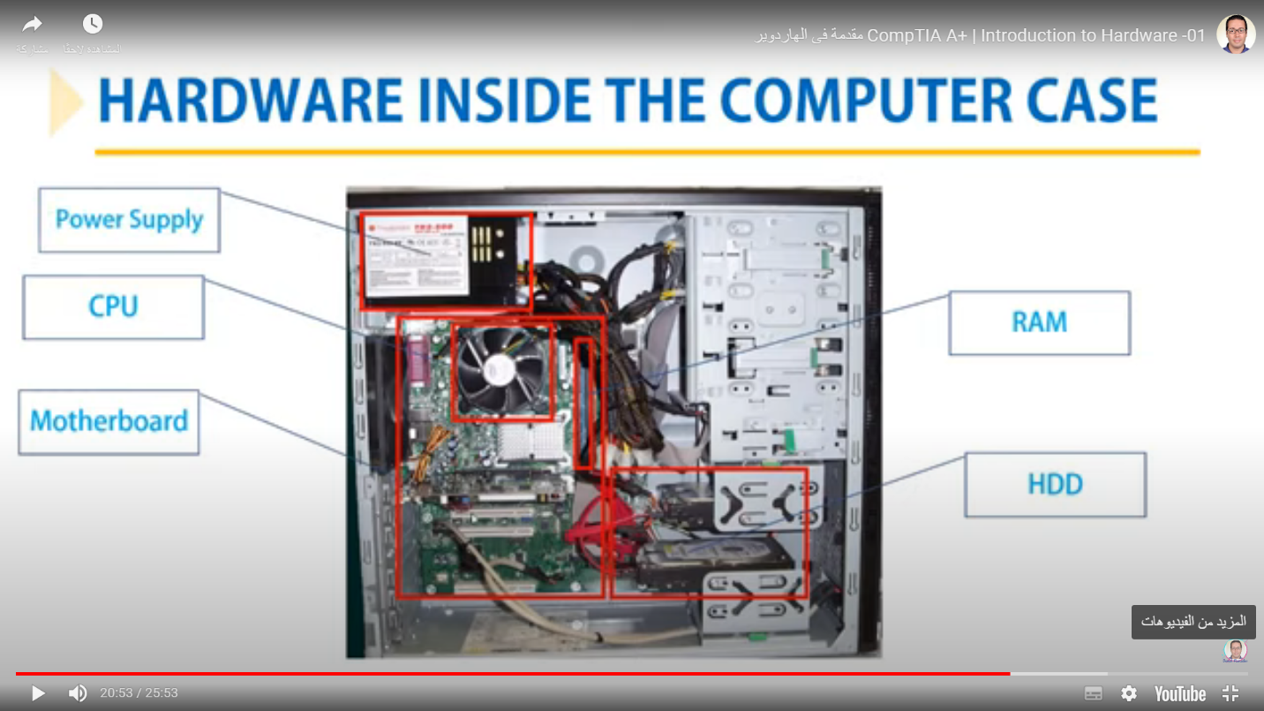

NOTES

* processing & storage are found in case

1. peripherals -> any component outside the case
2. to connect peripherals to case , I use I/O Ports

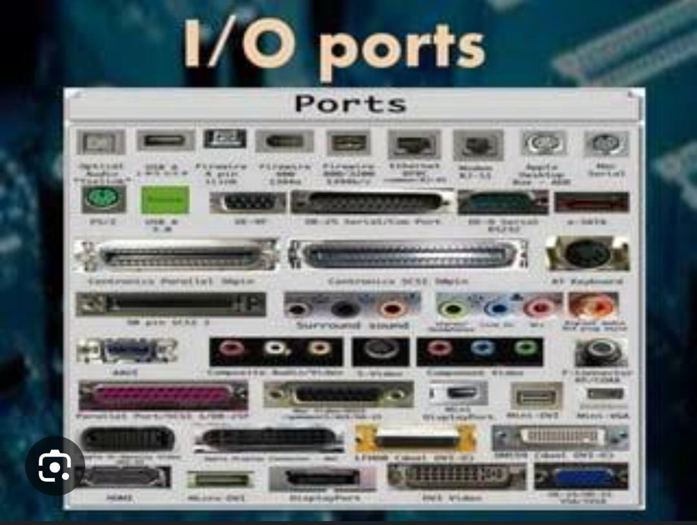

1. computer deals with the Binary System (ON -> 1 & OFF -> 0 ) language
2. (الكمبيوتر بيفهم لغه ال0 & 1 وعلشان تترجم على الشاشه واحنا نفهمها فدى بيعملها ال (operating System -> especially Windows))
3. Each hardware input , output , or storage device requires these elements to operate:
   * CPU -> to communicate with device.
   * Software -> to instruct and control the device.
   * Electricity -> to power the device.
4. Soft Copy -> the data generated by the screen ex (pdf , word)
5. Hard Copy -> the data generated by the Printer

**Form factor**

Info

* + Match (size & shape & major features ) to (case & Power Supply & motherboard)

Types

* + ATX ( Advanced Technology Extended)
    - Intel 1995
    - Place & shape
      * CPU is right of PCI Slots
      * The number of PCI Slots is three or more.
      * Rectangle
    - Connector

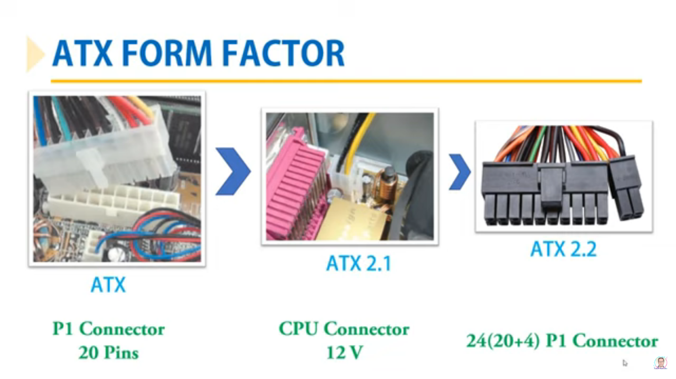

* + - Another features of an ATX motherboard is a soft Switch, sometimes called the soft power feature.

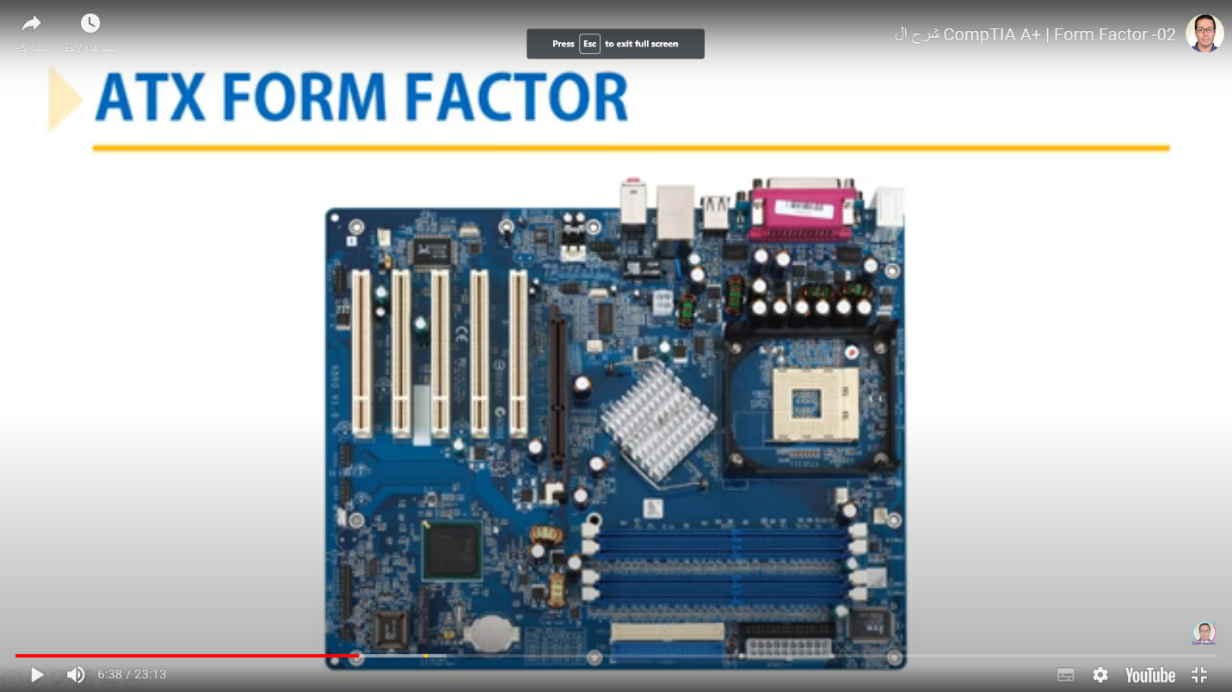

* + microATX
    - square
    - PCI slots is lower than one
    - The cost is lower
  + BTX ( Balanced Technology Extended)
    - Useful for ventilation
    - CPU has a cover as an installation for it

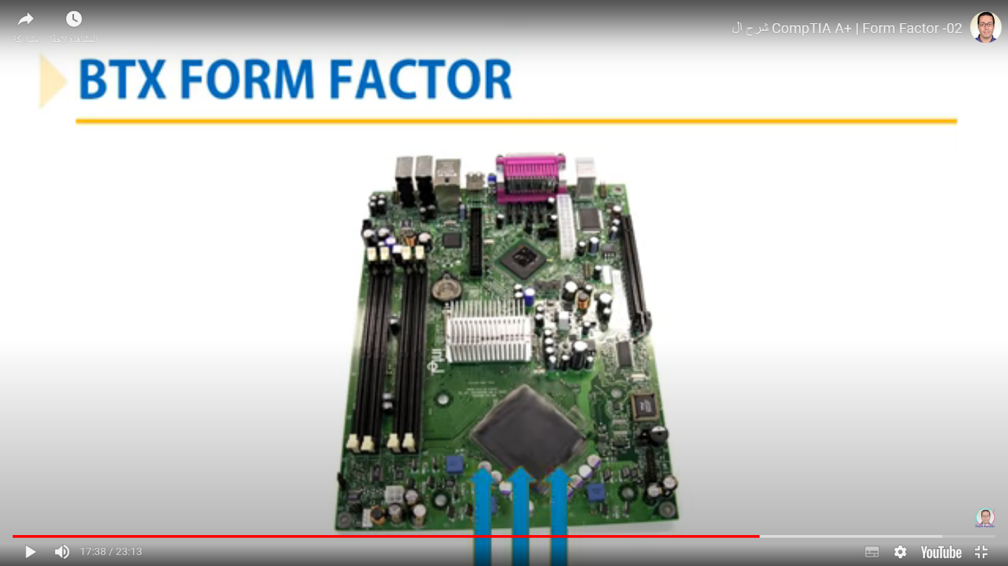

**Computer cases**

* Desktop
* (الكيسا النايمه) (حامل للشاشه)
* Midsize tower
* famous , cheap , places for disks
* Full-size tower
* for motherboard ATX form factor because of its large size

s